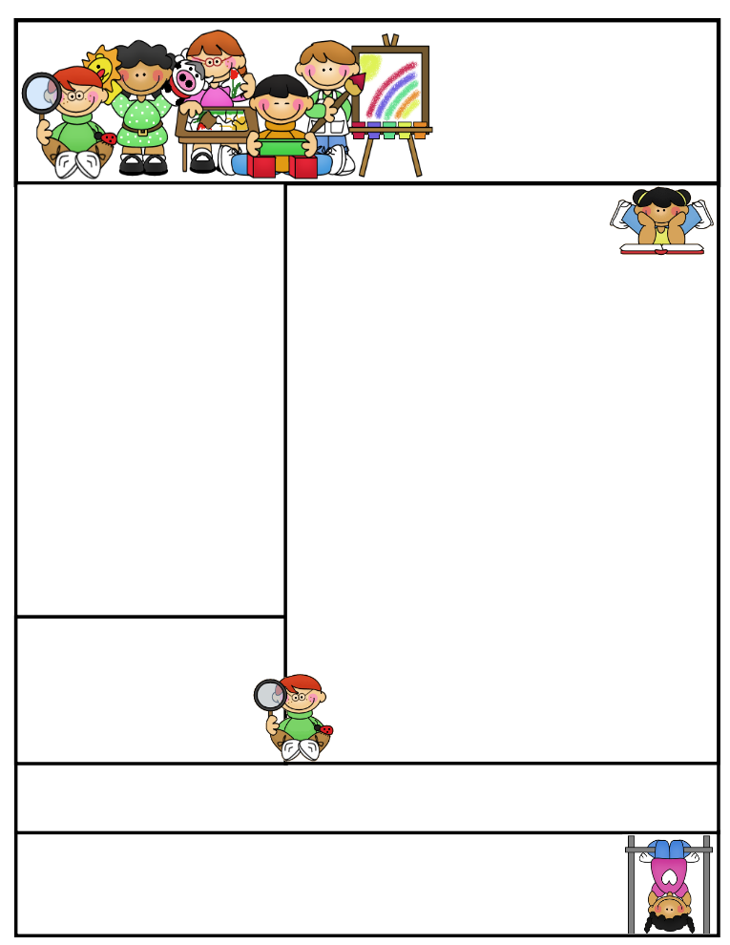

Mrs. Wolshon’s Class [wolshonj@huronacademy.org](mailto:wolshonj@huronacademy.org) Room 19  
(586) 446-9170 <https://lintons.us/haw/>

11401 Metro Parkway, Sterling Heights, MI 48312

**Our class is a Peanut/Tree Nut Free Room!** Please refrain from sending in foods containing nuts.

Mrs. Wolshon’s  
Newsletter

November 27, 2023

**“Student of the Week”**

**Xavier**



Important Dates:

November 27:

* School Resumes

November 29:

* Jean Day ($1.00-Athletic program fundraiser)

December 1:

* PTC Casual Day (for those who paid)

December 13:

* K-2 Holiday concert 6:10-6:40pm (doors open at 6:00pm at the Utica campus)

Classroom News:

* Just a quick reminder that we have lunch in our classroom on Thursdays. Please do not pack any items with nuts/peanuts for lunch or snack on Thursdays.
* We have Library on Wednesdays. Students may bring their Library books to school on Wednesdays if they want to get a new book.
* We have Gym on Thursdays. Students may wear their gym shoes on Thursdays if they wish.
* To support the Huron Academy Athletics Program, students may wear casual clothing for just $1.00 on November 29th.
* Our K-2 Winter Concert is December 13th at 6:10pm at the Utica campus. The doors open at 6:00pm. Students should wear an outdoor hat, coat, mittens and winter scarfs.

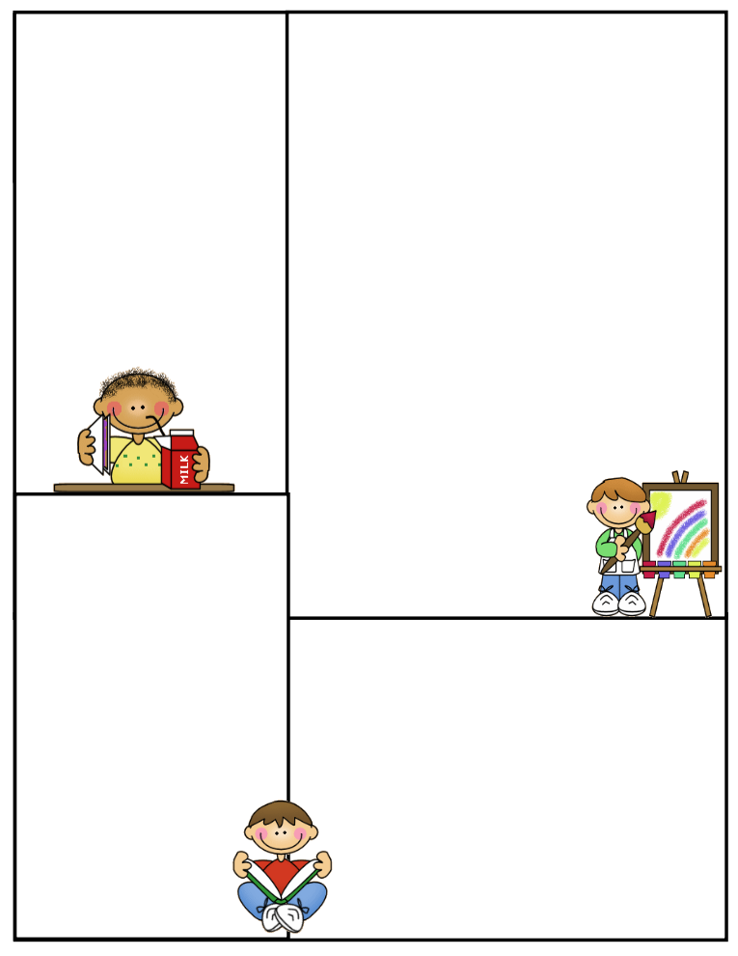

Specials (1:20-2:10):

Week 1: Computers  
Week 2: Art  
Week 3: Moby Max

(10:00-10:30)

Week 4: Gym

Week 5: Music

**\*\*Please note students may wear their gym shoes to school on Thursdays\*\***

Other Information Here:

* Please make sure your child has an extra set of clothing in their backpacks in case of emergency.
* PLEASE DO NOT SEND IN NUTS/PEANUTS FOR LUNCH ON THURSDAYS SINCE WE EAT IN OUR CLASSROOMS.
* Please make sure to return any necessary paperwork to the office.

Lunch:

11:00-11:25

Recess:

11:25-11:55

What We’re Learning:

**Reading**: We will continue switching classes for Reading this week. Students may stay with me or visit another teacher for Reading. We are working on telling the difference between fiction and non-fiction texts.

**Phonics**: Students will focus on Lesson #41-45 this week. Students will receive review work Monday-Thursday. **Our next test is Friday, December 1st.**

**Math**: We will practice subtraction this week. We will work on Topic 5 of our math curriculum. We will have review pages Monday-Thursday.

**Spelling:** Students received Spelling Packet #6 on Monday, November 27th.  **It is due December 1st. We also have a Spelling test on December 1st.**

**Science**: We will be learning about Light & Sky for the next few weeks.

**Writing**: We are working on writing complete sentences with subject, predicate, capital letters, punctuation, spacing and neat handwriting. We will write about Thanksgiving and using adjectives and complete sentences. We will begin working on our Santa letters soon.