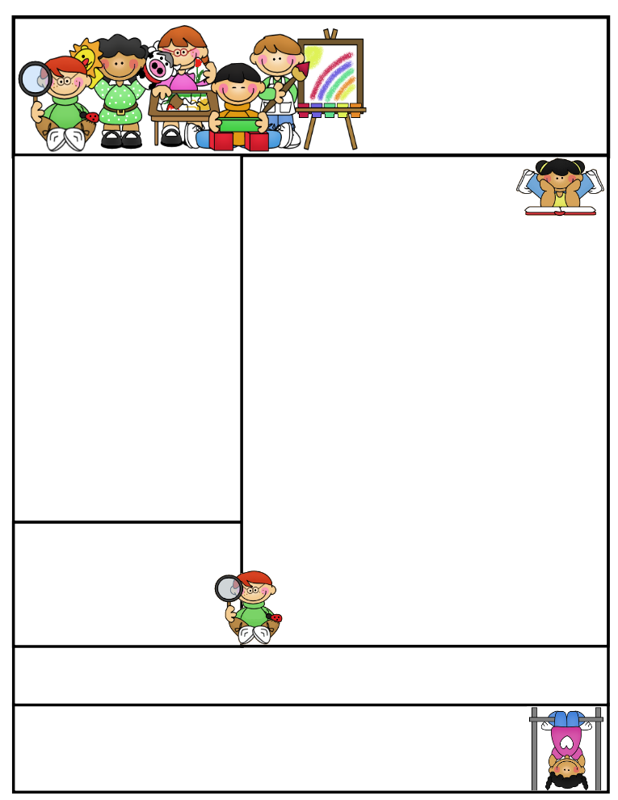

Mrs. Wolshon’s Class [wolshonj@huronacademy.org](mailto:wolshonj@huronacademy.org) Room 19  
(586) 446-9170 <https://lintons.us/haw/>

11401 Metro Parkway, Sterling Heights, MI 48312

**Our class is a Peanut/Tree Nut Free Room!** Please refrain from sending in foods containing nuts.

Mrs. Wolshon’s  
Newsletter

December 4, 2023

**“Student of the Week”**

**Jordan**



Important Dates:

December 12:

* Santa Shop (10:00-11:15)

December 13:

* K-2 Holiday concert 6:00-6:30pm (students report by 5:50pm)

December 15:

* Late Start Friday (10:13)

December 22:

* School closes at 3:30 for Christmas Break

December 25-January 5:

* Christmas Break

Classroom News:

* Just a quick reminder that we have lunch in our classroom on Thursdays. Please do not pack any items with nuts/peanuts for lunch or snack on Thursdays.
* We have Library on Wednesdays. Students may bring their Library books to school on Wednesdays if they want to get a new book.
* We have Gym on Thursdays. Students may wear their gym shoes on Thursdays if they wish.
* Our K-2 Winter Concert is December 13th at 6:00pm at the Utica campus. Please arrive by 5:50pm. Students should report to a classroom down the 3-5 grade hallway and I will watch them. Parents can find a seat in the Gym. Students should wear an outdoor hat, coat, mittens and winter scarfs.
* We are having a small holiday party on Friday, December 22nd. We will be enjoying some fun games, making a craft and competing holiday activities. Students may bring in 2-3 each snacks to enjoy during our party. Please do not send in any snacks containing nuts.

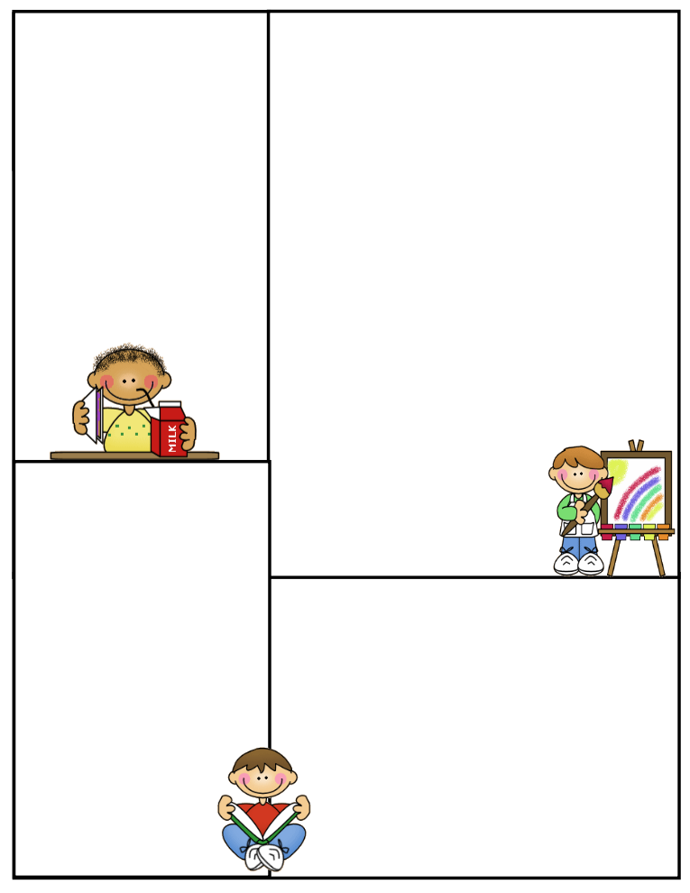

Specials (1:20-2:10):

Week 1: Computers  
Week 2: Art  
Week 3: Moby Max

(10:00-10:30)

Week 4: Gym

Week 5: Music

**\*\*Please note students may wear their gym shoes to school on Thursdays\*\***

Other Information Here:

* Please make sure your child has an extra set of clothing in their backpacks in case of emergency.
* PLEASE DO NOT SEND IN NUTS/PEANUTS FOR LUNCH ON THURSDAYS SINCE WE EAT IN OUR CLASSROOMS.
* Please make sure to return any necessary paperwork to the office.

Lunch:

11:00-11:25

Recess:

11:25-11:55

What We’re Learning:

**Reading**: We will continue switching classes for Reading this week. Students may stay with me or visit another teacher for Reading. We are working on telling the difference between fiction and non-fiction texts.

**Phonics**: Students will focus on Lesson #46-50 this week. Students will receive review work Monday-Thursday. **Our next test is Friday, December 8th.**

**Math**: We will practice subtraction this week. We will work on Topic 5 of our math curriculum. We will have review pages Monday-Tuesday. **We have a test on Friday, December 8th.**

**Spelling:** Students received Spelling Packet #7 on Friday, December 1st. **It is due December 8th. We also have a Spelling test on December 8th.**

**Science**: We will be learning about “Patterns in the Sky” for the next few weeks.

**Writing**: We are working on writing complete sentences with subject, predicate, capital letters, punctuation, spacing and neat handwriting. We will write our “Letters to Santa” and using adjectives and complete sentences.