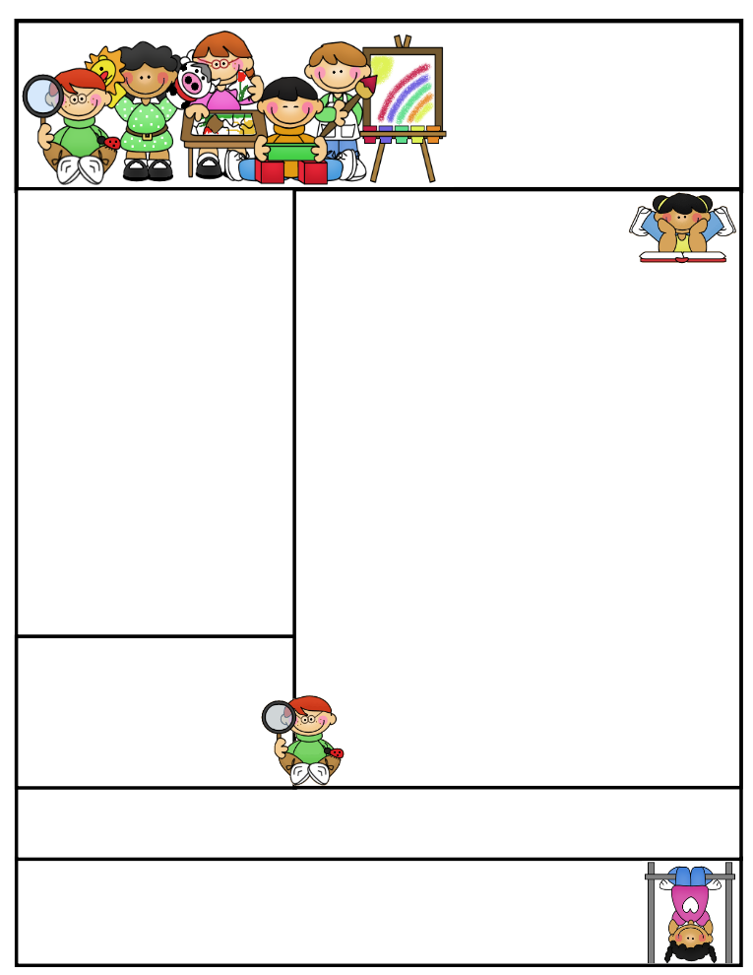

Mrs. Wolshon’s Class [wolshonj@huronacademy.org](mailto:wolshonj@huronacademy.org) Room 19  
(586) 446-9170 <https://lintons.us/haw/>

11401 Metro Parkway, Sterling Heights, MI 48312

**Our class is a Peanut/Tree Nut Free Room!** Please refrain from sending in foods containing nuts.

Mrs. Wolshon’s  
Newsletter

December 18, 2023

**“Student of the Week”**

**Angelo**



Important Dates:

December 22:

* School closes at 3:30 for Christmas Break

December 25-January 5:

* Christmas Break

January 8:

* School Resumes

January 12:

* Late Start Friday (10:13)
* PTC Casual Day for those who paid

January 15:

* No School (Martin Luther King, Jr. Day)

Classroom News:

* We have Library on Wednesdays. Students may bring their Library books to school on Wednesdays if they want to get a new book.
* We have Gym on Thursdays. Students may wear their gym shoes on Thursdays if they wish.
* This week is Spirit Week. Students may wear casual clothing if they follow the theme of the day. There is no cost to participate.
  + Monday-Crazy Hat/Hair Day
  + Tuesday-Sweats and Slippers Day
  + Wednesday-Favorite Color Day
  + Thursday-Inside Out/Backwards Day
  + Friday-Holiday Day
* We are having a small holiday party on Friday, December 22nd. We will be enjoying some fun games, making a craft and competing holiday activities. Students may bring in 2-3 snacks each to enjoy during our party. Please do not send in any snacks containing nuts. Students can send in goodie bags (without food) to pass out if they wish. We have 19 students.
* Our holiday break runs from December 25th-January 5th. School will be closed for on those dates. School resumes on January 8th.

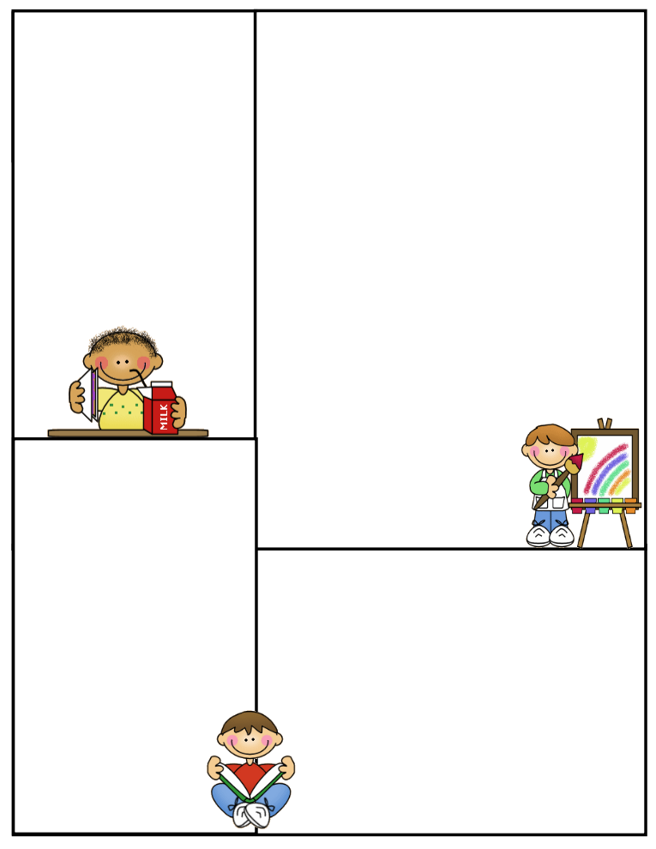

Specials (1:20-2:10):

Week 1: Computers  
Week 2: Art  
Week 3: Moby Max

(10:00-10:30)

Week 4: Gym

Week 5: Music

**\*\*Please note students may wear their gym shoes to school on Thursdays\*\***

Other Information Here:

* Please make sure your child has an extra set of clothing in their backpacks in case of emergency.
* PLEASE DO NOT SEND IN NUTS/PEANUTS FOR LUNCH ON THURSDAYS SINCE WE EAT IN OUR CLASSROOMS.
* Please make sure to return any necessary paperwork to the office.

Lunch:

11:00-11:25

Recess:

11:25-11:55

What We’re Learning:

**Reading**: We will continue switching classes for Reading this week. Students may stay with me or visit another teacher for Reading. We are working on learning how illustrations help readers understand the story.

**Phonics**: Students will focus on Lessons #56-60 this week. Students will receive review work Monday-Thursday. **Our next test is Friday, December 22nd.**

**Math**: We will practice using data this week. We will work on Topic 6 of our math curriculum. Students will receive review work on Thursday only. **We will have a math test on Wednesday, December 20th.**

**Spelling:** Students received Spelling Packet #9 on Friday, December 15th. **It is due December 22nd. We also have a Spelling test on December 22nd.**

**Social Studies**: We are learning about different holidays celebrated around the world.

**Writing**: We are working on writing complete sentences with subject, predicate, capital letters, punctuation, spacing and neat handwriting. We will write our “Letters to Santa” and use adjectives and complete sentences.